# PEBA 6609 - Ticket

Incorrect file name – should be RL2 however it’s showing 2022 T4A

Last year’s RL2 is also being labeled a T4A – sending email to Steve Green to see if this can be fixed in house – also sending JEA ticket regarding this issue. Will test in training region prior to sending ticket.

PEBA 6609 - Ticket

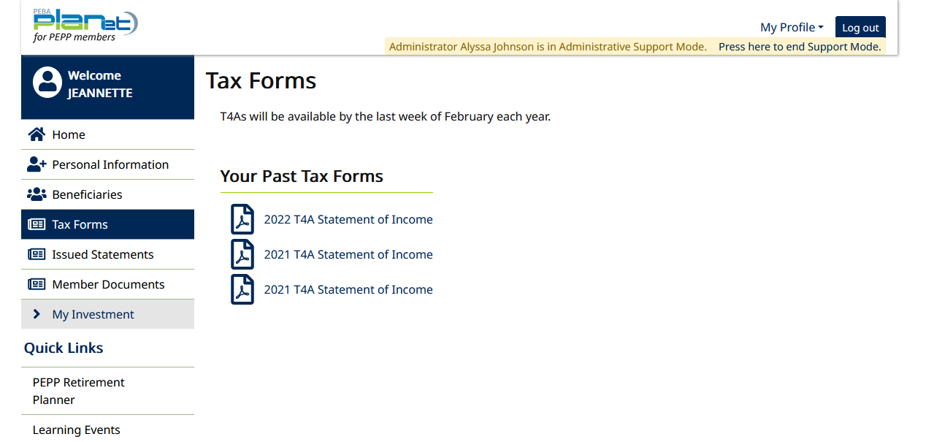

This issue is currently in production

This issue is also occurring with NR4 Slips

Impact is approx. 100 members for 2021 slips

Emailed Steve Green to see if this is something we can fix in house, and also submitted ticket to JEA.